Phase 1 – Project Plan

Series Tracker App

Couch Potatoes

Ambelal, S u21439321

Moshokoa, IJ u21785742

Modise, ZM u21508322

Siphuma, A u21556416

Email address for feedback: u21785742@tuks.co.za

| Needs Identification [10] | User Identification  [20] | User needs  [10] | Conceptual Design  [10] | Total  [50] |
| --- | --- | --- | --- | --- |
|  |  |  |  |  |

Question 2: Needs Identification

**Problem space:**

The problem space for our series tracker app revolves around the challenges users face in managing their television or online series watching habits. With the rapid growth of streaming services and the large pool of available content, users often find it difficult to keep track of what they're watching, remember when new episodes are released, and organize their viewing schedule efficiently. Additionally, users may want to discuss episodes or share their thoughts with others, enhancing their overall viewing experience.

**Needs verification:**

The primary need that makes users to use a series tracker app is the desire for organization and better management of their streaming habits. An app that can:

1. Track Progress: Users want to keep track of which episodes they've watched, how far into an episode they are (time frames) and which ones they haven't, across multiple series. This ensures they don't miss any episodes and can easily pick up where they left off.
2. Discover New Content and Personalised Recommendations: Users may want recommendations or suggestions for new series based on their viewing preferences i.e., genre, year, country, trending or shows having a specific actor/actress.
3. Integration: Users want to be able to integrate the app with their popular series watching platforms.
4. Unified Dashboard: Provide a single interface for users to track all their favourite series, including upcoming releases, recently aired episodes, and personalized recommendations.
5. Integrated Content: Curate supplementary content such as trailers, interviews, and articles related to the series within the app for a more immersive viewing experience. e.g., Apple TV
6. Ratings and Reviews: Users may want to see reviews and ratings of recommended shows before watching.
7. Tracking System: Calendar view of what you watched already and show how long it's been since you watched a series.
8. Personalized User Experience: When a user signs up to the app they can choose different genres and topics that are of interest to the user.
9. Interactive Community: Rating system and make friends with others on the app to share recommendations.
10. View party: Integrate the ability to use a watch party system to view series progress of your friends online.

**Why existing solutions do not aptly serve the users’ needs:**

1. User Interface: Most apps do not have the most pleasing user interface(they are quite hard to navigate and one has to search for options instead of them being readily available e.g side tab) and as we know “A user interface is like a joke, if you have to explain it, it’s not that good” - Martin Leblanc
2. Lack of diversity: Certain shows or genres are not uploaded on the apps which makes users not download those.
3. Integration: Some apps may lack integration with popular streaming platforms which means they’ll have to manually insert the series they are watching.
4. Poor Content Discovery: Existing apps may not offer effective recommendation algorithms or curated content suggestions, making it challenging for users to discover new series tailored to their interests.

Our series tracking app aims to offer solutions to the above-mentioned shortcomings and offer other features.

Question 3: User Identification

a) **Identify the (general) user base of your product and describe it.**

The series tracker app caters to a diverse user base of consumers of serialised media including, but not limited to web series, documentaries, television shows, and anime. These individuals often rely on one or more platforms to watch and discover content they enjoy.

Users of the app are mainly driven by their need for entertainment. Most streaming platforms provide no way to monitor a user's viewing habits, which is the main reason users opt to use a series tracker. It’s nearly impossible to manually remember one’s streaming activity and progress. The app serves as a centralised tool of convenience for users to organise, track and engage in their favourite television series.

Users enjoy tracking their streaming habits, and progress across series they are currently watching by viewing the amount of time it will take to finish a season, viewing the number of hours they have spent watching a particular series or series in general, and viewing the watch calendar in the app to see how often they watch series. The calendar also informs a user of the date they watched an episode. They can see which shows are in progress, and which shows they have not started yet, from their watchlists.

The users in the user base often struggle to find new series to watch, but fortunately, the tracker recommends series based on a user’s preferences or watch history.

Users organise their watching efficiently because the app ensures they are up to date with new releases. By providing timely notifications and updates on the latest releases, the app keeps users informed about new episodes, seasons, and series additions across multiple platforms. This real-time information empowers users to stay ahead, allowing them to plan their viewing schedule accordingly and prioritize the series that align with their interests and preferences.

The interactive community aspect of the app is particularly attractive to these users as they can engage in discussions, share insights, and potentially even form groups based around a particular series or topic.

b) **How do the user groups differ?**

1. **Binge watchers**: Binge watchers often consume several series at once or watch several episodes of a show in one sitting. Their primary motivation lies in the pure enjoyment and escapism that binge-watching provides. For binge watchers, series serve as a form of entertainment that offers excitement, suspense, and emotional engagement. They are driven by the desire to explore captivating storylines, unravel complex characters, and experience the thrill of narrative discovery.

2. **Social viewers:** Social viewers watch series as a shared experience with friends or online communities. They enjoy discussing episodes, sharing theories, and engaging in fan activities. They often seek platforms where they can interact with others who share their interests. They rely on user ratings to guide them in choosing a series to watch, as they value the opinions of other users. They value features that allow them to connect with friends, join discussions, and contribute to an online community. They tend to interact more with the community features of the app and are likely to share their progress and experiences on social media.

3. **Education-driven users**: people who use series as a tool for learning and to discover new documentaries, historical dramas or to learn more about a certain field, such as true crime. Education-driven users approach series watching with a purpose beyond mere entertainment; they view it as a valuable opportunity for personal growth and knowledge acquisition.

For them, watching series is not just a leisure activity but an investment in lifelong learning and personal growth. They seek to better understand the world around them. Their thirst for knowledge is the main reason they desire to find informative content that deepens their understanding of diverse subjects, cultures, and historical events.

c) **How does each user group use the app?**

1. **Binge watchers** use the series trackers to organise their binge-watching sessions. They often use several different platforms to watch series. This is because they want to access a wide variety of content that may be exclusive to different streaming services. By utilising multiple streaming services, binge watchers can satisfy their appetite for entertainment while enjoying the convenience and flexibility that modern technology provides.

It is therefore convenient to track their progress across different platforms using just the series tracker. They also keep track of episodes they’ve watched using the calendar feature, which functions as a watch history, and keep up to date with releases, due to notifications and reminders. Additionally, accessing content from various platforms enables them to discover new shows and genres they might not have encountered otherwise, enhancing their overall viewing experience.

2. **Social viewers** use the app to connect with other series enthusiasts. They communicate with others through the community features. Notifications play a crucial role in keeping them engaged and informed about new discussions, and opportunities to participate in fan-driven activities. They often engage in discussions, share theories, and create or join fan groups. This group also utilises the group viewing or watch party feature to watch series with friends and discuss episodes in real-time. The watch party allows them to host a virtual room in which they can watch episodes with others in real-time. In this virtual room, viewers can verbally express their opinions as they watch or to use the chat feature to comment.

3. **Educational users** use the series tracker app to discover educational or documentary series that align with their academic interests or personal development goals, as the app recommends series based on a user's interests. They create watchlists tailored to their topics of interest. Educational users engage with community features within the app to exchange insights with like-minded individuals, recommendations, and supplementary resources related to educational TV content.

Question 4: User Needs

**General User Needs:**

Personalized Recommendations: The app should provide personalized recommendations for series across various genres to cater to the diverse interests of the user base. This feature ensures that users can easily discover new content aligned with their preferences, enhancing their overall viewing experience.

Tracking and Organization: The app must offer a centralized platform for users to organize and track their viewing habits across multiple streaming platforms. This feature allows users to efficiently manage their watchlists, track their progress across series, and stay up-to-date with new releases, irrespective of the platforms they use.

Notifications and Updates: Providing real-time notifications and updates about new episodes, seasons, and series additions is essential for keeping users informed and engaged. This feature empowers users to plan their viewing schedule effectively, prioritize their interests, and ensure they never miss out on new releases.

Community Engagement: The app should facilitate interactive community engagement, allowing users to connect, discuss, and share insights with like-minded individuals. Community features such as discussion forums, group viewing/watch parties, and sharing functionalities enhance user engagement and foster a sense of belonging within the user base.

**Binge Watchers:**

Platform Integration:

Binge watchers require seamless integration with multiple streaming platforms to access a wide variety of content. This also ensures that users are guaranteed a platform to watch their desired content in the event that one platform is down. The app should support integration with popular streaming services to enable users to track their progress across different platforms effortlessly.

Progress Tracking:

Binge watchers need efficient progress tracking features to monitor their binge-watching sessions. Features like detailed watch history, binge progress indicators, and personalized binge recommendations cater to their specific viewing habits and preferences.

**Social Viewers:**

Enhanced Community Features:

Social viewers value interactive community engagement and require enhanced features for connecting with other series enthusiasts. The app should offer robust community features such as real-time discussions, fan groups, and watch parties to facilitate meaningful interactions and foster a sense of community among users.

User-Generated Content Integration:

Social viewers seek platforms where they can contribute their own content and engage with user-generated content. Integrating features for user-generated reviews, recommendations, and content creation enhances the overall user experience for social viewers.

**Education-Driven Users:**

Educational Content Recommendations:

Education-driven users rely on the app to discover educational and documentary series aligned with their academic interests and personal development goals. The recommendations should be categorised into documentaries, docu-series, historical movies etc. The user should be allowed to take the recommendations and add them to their own series playlists for ease of access. The app should prioritize recommending high-quality educational content and provide tailored suggestions based on users' academic preferences and learning objectives.

Supplementary Learning Resources:

Education-driven users require access to supplementary learning resources to deepen their understanding of educational TV content. Features such as curated resource lists, educational articles, and expert recommendations enhance the educational value of the app and support lifelong learning initiatives.

Question 5: Conceptual Design

**Summary of user response:**

Users have provided feedback on the product, describing it as an application designed to assist in managing watched series similar to anime watchlist (which is an anime and manga social networking and social cataloging application website, that provides its users with a list-like system to organize and score anime and manga.). It offers users information and ratings on ongoing shows, with an expectation for notifications regarding similar series availability and seamless tracking of viewing progress. Users anticipate intuitive navigation within the app, making it particularly suitable for binge-watchers and TV enthusiasts. Drawing from experiences with similar applications, users desire features like real-time updates on current series and integration with favorite streaming services for up-to-date tracking of the current series they are watching.

**AI Generated Images of a Series Tracker based on the description given by users**

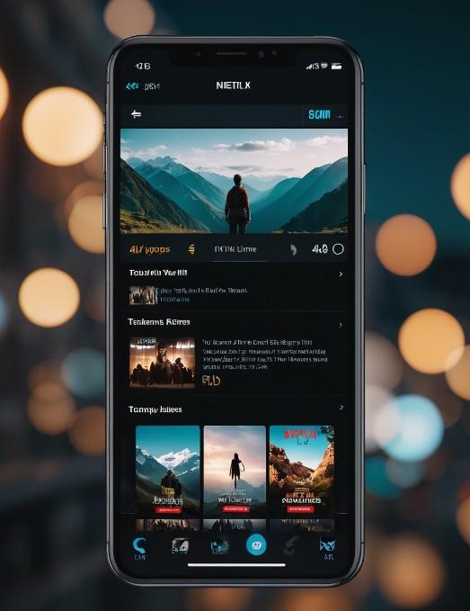

[Bad Design Feature] The application currently operates solely in dark mode, potentially hindering user visibility and readability.

[Solution] By integrating a toggle feature enabling users to switch between light and dark modes, the application aims to enhance accessibility, usability, and personalization, thereby encouraging a more engaging and inclusive user experience.

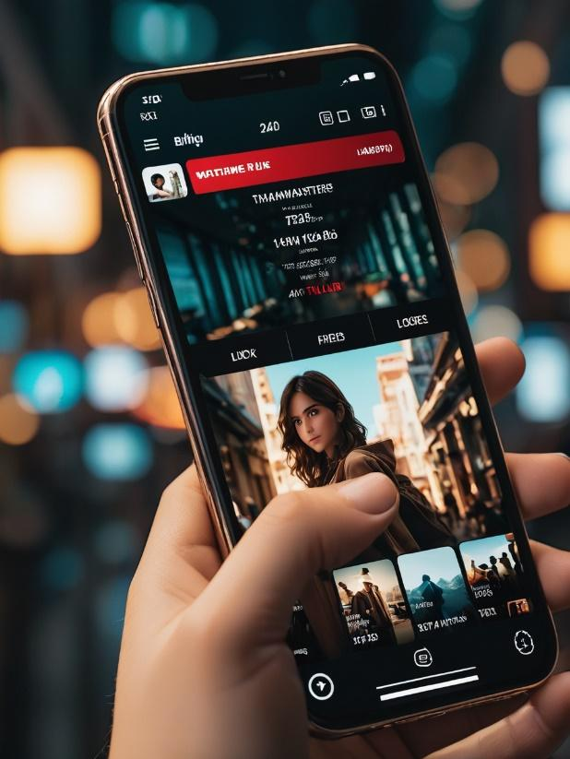



[Bad Design Feature] the excessive number of task bar navigations present within the app interface. The abundance of button components on both the top and bottom navigation bars contributes to visual clutter and may potentially overwhelm users, leading to confusion.

[Solution] Implement a single task bar, with few components that emphasize key pages within the app

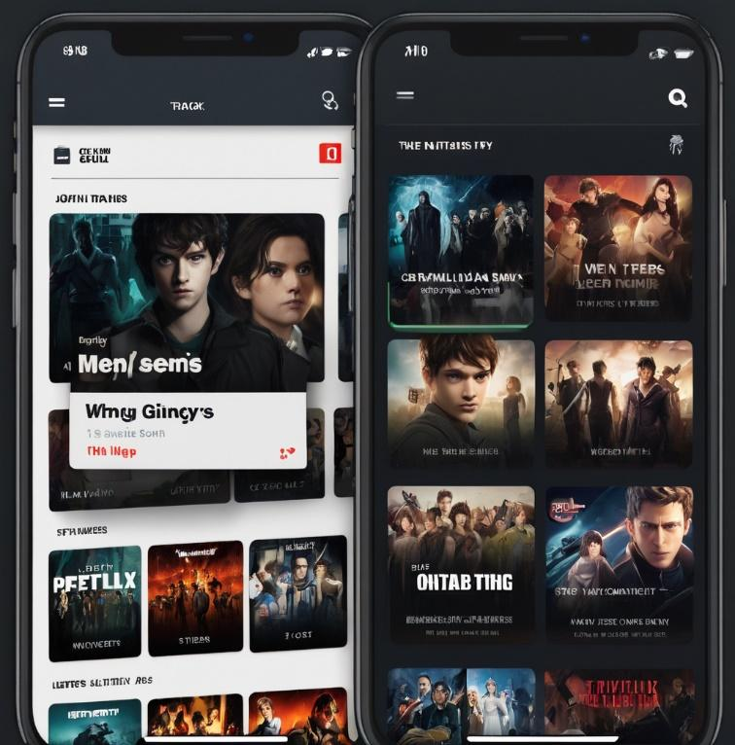

[Bad Design Feature] The current design of the app features slanted categories that users can slide through, potentially making it harder for navigation and readability. Additionally, the presentation of series information overlaps with these categories, leading to a cluttered interface and hindering the accessibility of important information / details.A screenshot of a phone

[Solution] We can straighten the category alignment to ensure they are displayed in a straight and organized manner, promoting easier navigation for users as they browse through different sections, and we can also make a user-friendly mechanism where users can click on the series directly to access additional information, rather than relying on overlaid content – this approach will maintain clarity and prevents visual clutter.

Some innovative elements we seemed to find:

The bottom task bar navigation on *figure 1* which offers users convenient access to all other pages within the app and ensures easy navigation.

The Search page on *figure 3* that gives the users an organized display of series names and associated ratings. This symmetrical layout enhances visual clarity and gives effortless exploration to the user.

The genre-based catalogues on *figure 3* are an element we could also use to allow users to effortlessly slide through series listings categorized according to genres. This feature would enhance content discovery by offering users curated selections aligned with preferences.

***Attached in the zip are the user responses.***